BATTULA RAJANNA | 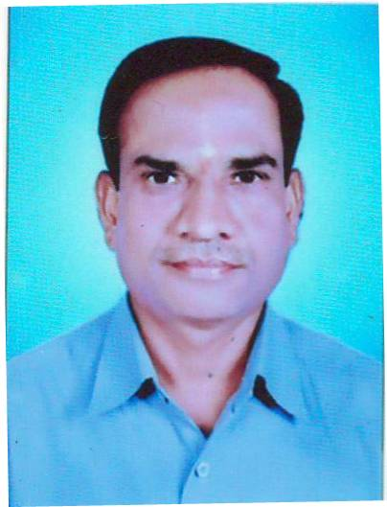
Qualification : M.Tech (Ph.D)
Experience: 2008-TILL TO DATE (10 Years)
Area of Interest: WIRELESS & MOBILE COMMUNICATION
Subjects Taught: OPTICAL COMMUNICATIONS,RADAR SYSTEMS,ANALOG COMMUNICATIONS,DIGITAL COMMUNICATIONS,ADVANCED DATA COMMUNICATIONS,WIRELESS &MOBILE COMMUNICATIONS,MIMO.
Research Publications:
- ADAPTIVE SYMBOLS AIDED FOR RELAY ASSIGNMENT FOR CHANNEL ESTIMATION FOR MIMO-OFDM SYSTEM International Journal of Pure and Applied Mathematics Volume 116 No. 23 2017, 237-244 ISSN: 1311-8080 (printed version); ISSN: 1314-3395
- Optimized Power Allocation and Cooperative Relay Selection in Communication System ICAECS 2016
- MIMO-OFDM based Cognitive Radio Systems with Imperfect Spectrum Sensing by Multi-objective Optimization Technique nternational Journal of Control Theory and Applications ISSN : 0974-5572 Volume 10 • Number 12 • 2017
- Multi-hope relay based high capacity energy efficient model for ultra wideband communication system International Journal of Engineering & Technology 7 (1.5) (2018) 118-121
No of Projects guided:
UG | PG
15 | 12

Workshops/Seminars/FDP’s Organized:
01.PCB DESIGNE-2015
Workshops/Seminars/FDP’s Attended:
01.CONTINUING EDUCATION PROGRAMING ON 4G TECHNOLOGY-2015
ORGANISED BY-NIT WARNGAL ECE DEPT.
02. 01.CONTINUING EDUCATION PROGRAMING ON 5G TECHNOLOGY-2018
ORGANISED BY-NIT WARNGAL ECE DEPT.
03. ISTE workshop attended in Signals & systems conducted by BITS 2014

