Balaji Bhukya | 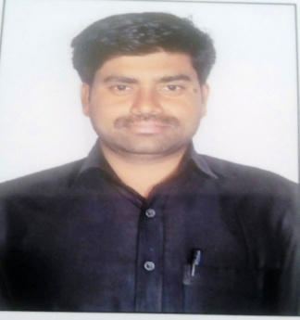
Qualification : M.Tech

Experience: 10 years

Area of Interest: Instrumentation

Subjects Taught: EMI, MPMC, EDC, and Industrial Electronics

Research Publications:
1. Low power Implementations of booths multiplier using reversible Gates B.Balaji International Journal for Modern Tends in Science & Technology, Vol.2, issue: 10, Oct,2016, ISSN 2455-3778.
2. Design Of Accumulator based 3-weight pattern Generation using LP-LSFR B.Balaji
IOSR Journals Vol.7, Issue:3, Sep-Oct, 2013
3. Robust object tracking using joint color –Texture Histogram B.Balaji
National Conference on Wireless Communications and VLSI Design on 29th may 2011.
4. Blind equalization of SIMO channels using CMA and FS-CMA. B.Balaji
International Journal of Computer Science Information & Engineering Technologies Vol.3,
Issue 4, on Sep, 2014, ISSN (online): 2277-4408
5. Adaptive low power Implementations of an on Chip Permutation network for multi
Processors System-on- Chip B.Balaji International conference on Electronics, Communications and VLSI circuits on July 10th 2015
No of Projects guided:
UG | PG
15 | 05

Workshops/Seminars/FDP’s Attended:
- One day workshop on Defense Electronics” conducted at Kakatiya University on 5th Feb, 2014.
- A two week iste workshop on Signals and systems conduted by iit kharagpu at BITS Warangal. From 2nd Jan to 12th jan, 2014.
- AICTE Sponsored SDP on “Hands on Digital Signal Processing Tools , Algorithms and Architecture’ conducted at JITS, Warangal from 7th -19th Dec 2009.
- A three day workshop on “Embedded system design using ATMEL XMEGA XPLD A1 and ARM based SAM 4L” conducted by JNTUH from 22-25th Feb, 2014.
- A one week workshop on VLSI and Embedded Systems conducted at VECW, from 13th -20th Sep, 2011.

