RAJASHEKAR THALLAPALLI | 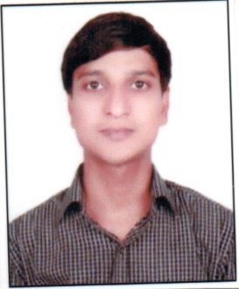
Qualification : M.E (OSMANIA UNIVERSITY)
Experience: 6 YEARS
Area of Interest: Communications
Subjects Taught: MWE,DSP,PDC,STLD,ECA & CS
No of Projects guided:
UG | PG
6 | 4

Workshops/Seminars/FDP’s Organized:
- A 3 DAY NATIONAL WORKSHOP ON IOT, OCT 2017 AT VCEW ,BOLLIKUNTA
Workshops/Seminars/FDP’s Attended:
- A 6 DAY NATIONAL WORKSHOP ON ADSP ,AT NITW WARANGAL.
Achievements:
- Qualified in UGC –NET-2013 (DEC)

