SATHEESH AKULA | 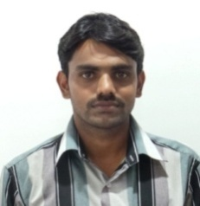
Qualification : M.TECH IN EMBEDDED SYSTEMS

Experience : 6 years

Area of Interest: EMBEDDED SYSTEMS

Subjects Taught:
1.ANALOG COMMUNICATIONS
2.ELECTRONIC CIRCUIT ANALYSIS,
3. ELECTRONIC DEVICES & CIRCUITS
4.RADAR SYSTEMS,
5.EMBEDDED SYSTEMS
6. ELECTRONIC CIRCUITS
7. EMBEDDED SYSTEM DESIGN
No of Projects guided:
UG | PG
11 | 5

Workshops/Seminars/FDP’s Organized:

- I have organized a two days national level work shop on “QUAD COPTER” which is conducted by the department of ECE Vaagdevi Engineering College .

Workshops/Seminars/FDP’s Attended:
- I have attended the work shop on ‘Recent Trends In Embedded Systems’ conducted by the ANURAG GROUP OF INSTITUTIONS,GHATKESAR.
- I have attended the work shop on ‘COMPUTER PROGRAMING’ CONDUCTED BY IIT BOMBAY
- I have attended the ‘Faculty Development Program’ on EMBEDDED SYSTEMS at NIT, Warangal.
Conferences Attended:
- I have attended the” INTERNATIONAL CONFERENCE” at SR ENGINEERING COLLEGE
Achievements:
- I GOT 6th RANK IN “STATE LEVEL GK COMPETITION”

