HARIKRSIHNA B | 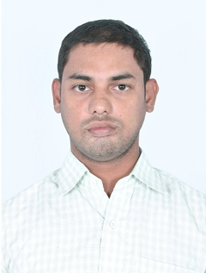
Qualification : M.Tech (DS&CE)
Experience: 6 YEARS
Area of Interest: VLSI SYSTEM DOMAIN
Subjects Taught: IC Application, STLD,DLD,PD&LIC
No of Projects guided:
UG | PG
4 | 6

Workshops/Seminars/FDP’s Attended:
- Participated in a Two-Week ISTE Workshop on “Computer Programming” conducted by Indian Institute of Technology Bombay, During May 20th to June 21st 2014.
- Attended an IETE Sponsored Faculty Development programme on "Advanced VLSI Design-Hands on Experience with CAD tools” conducted by CMR College of Engineering Hyderabad, During 19th to 24th December 2014.

