Naganaboina Haritha | 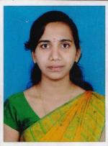
Qualification: M.Tech

Experience: 5yrs

Area of Interest: Communications

Subjects Taught:

SS, PSP, CO, DLD, DSP, MPMC & DDTV.
No of Projects guided:
UG | PG
8 | 3

