Radhika.Gudi | 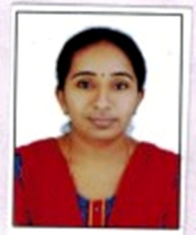
Qualification : M.Tech ,KITS WARANGAL.

Experience: 6 years

Area of Interest: VLSI Design

Subjects Taught: 1. VLSI design
2. Electronic Devices and Circuits
3. Switching theory and logic Design
4. Electronic Measurements and Instrumentation
5. Pulse Devices and circuits
6. Analog Electronics

Research Publications:

- Participated in NCARC’13(National Conference on Advanced Research in Computing) and presented a paper titled “Design and Implementation of High Speed FET Processor for OFDMA System using FPGA”
- Automatic Irrigation System based on IOT and Embedded Linux High End Processor is published in international journal for innovative engineering and management research(IJIEMR).
- Design and implementation of BIT level optimization of Adder SW-TREE for MCM for FIR filter. . Is published in international journal of innovation engineerimg and management research (IJIEMR) , vol-06,issue -12,dec-2017.
- Shared steering control between a driver and an automation :stability in the presence of driver behavior uncertainty. Is published in international journal of innovation engineerimg and management research (IJIEMR) , vol-06,issue -12,dec-2017.

No of Projects guided:
UG | PG
10 | 3

Workshops/Seminars/FDP’s Attended:
- “Full custom IC Design & FPGA Design flow” organized by Vignana Jyothi Institute of Engineering & technology, Hyderabad.
- “Advanced Signal Processing Techniques in communications (ASPTC) 2013 organized by KITS Warangal.

Achievements: Received “Rajya puraskar” award from bharat scouts and guides.

