GANNA KOTESWARA RAO | 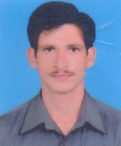
Qualification :
M. Tech (PhD - JNTU,Hyderabad)

Experience: 9 Years

Area of Interest: Signal Processing

Subjects Taught: MPMC, DSP, DSPA, STLD, DLD, SS,PDC,ICA,CMC,EC

Research Publications:
- MMSE sorted scheme for MIMO transmission using power control, IJETAE, ISSN:2250-2459, Volume 7,Issue 9, September 2017
- MMSE-SQRD Scheme for MIMO Transmission, IJR, e-ISSN:2348-6848, p-ISSN:2348-795X, Volume 04, Issue-17,December 2017
UG | PG
18 | 10
No of Projects guided:

Workshops/Seminars/FDP’s Organized:
- Two day national level workshop on “Recent trends in embedded systems using ARDUINO”
Workshops/Seminars/FDP’s Attended:
1.one week workshop on advances in wireless communications
2.A two day workshop on MATLAB programming and its applications

Conferences Attended:
1. International conference on innovative trends in engineering and management

Achievements: Topper in M Tech (Embedded Systems) during the academic year 2009-11 from Ramappa Engineering College

