Devarakonda Chandana | 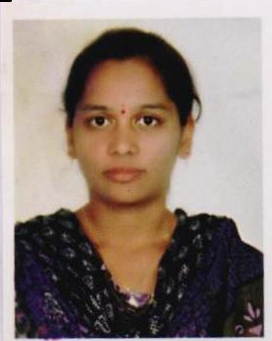
Qualification : M. Tech (Wireless Mobile Communication)
Experience: 03 years
Area of Interest: Communications
Subjects Taught: AC,DC &BE.
No of Projects guided:
UG
1

