UDUTHA SARITHA | 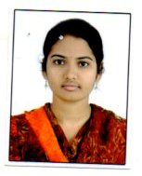
Qualification:
M.Tech (VLSI SYSTEM DESIGN)- KAKATIYA UNIVERSITY

Experience:
I'm working as a assistant professor in vaagdevicollege of engineering from January 2017 to till date.

Area of Interest: Analog and digital electronics

Subjects Taught: Computer organization

No of Projects guided:
UG | PG
1

