Name: Alakunta Santosh Kumar  Assistant Professor | 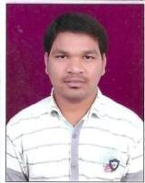
Qualification : M.Tech

Experience (write a brief paragraph): 1year 5 months
- Working as an Asst Professor from 2nd Feb 2017 to till now in (1 Year 5 months) Vaagdevi College of Engineering.
Area of Interest: concrete technology,CTPM,surveying,surveying lab,Estimation and costing.
Subjects Taught: CTPM.
Research Publications:(IEEE reference format)
- Development of interactin daigrams of steel beam column.
Workshops/Seminars/FDP’s Attended:
- Actively Participated in Workshop on Pavement Design, Construction Management System.

