Name:ARAVINDA V | 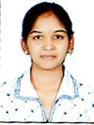
Qualification : M.tech -JNTUH,
B.Tech -JNTUH,
Intermediate- Board of Intermediate,
SSC-Board of Secondary School.

Experience:3years
Area of Interest: Web Technologies

Workshops/Seminars/FDP’s Attended:Delsoft , Soft computing.

