Name: Addagatta Ashok  Assistant Professor | 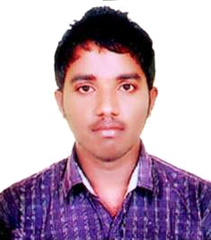
Qualification : M.Tech.

Experience : 2 years 6months
- Working as an Asst Professor from 12th Dec 2015 to till now in (2 Year 6 months) Vaagdevi College of Engineering.
Area of Interest : Highway Engineering
Subjects Taught : Structre Analysis, DRCS,DSS, Strength of Materials

Workshops/Seminars/FDP’s Attended:
Workshop – 1
- Actively participated in workshop on Pavement Design, Construction & Management System.

