Name: Bollam Mahesh  Assistant Professor | 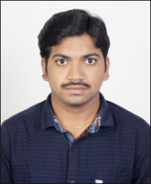
Qualification : Mtech.

Experience : 1year 5months
- Working as an Asst Professor from 02nd Jan 2017 to till now in (1 Year 5 months) Vaagdevi College of Engineering.
Area of Interest : Transportation Engineering
Subjects Taught : Transportation Engineering
Workshops/Seminars/FDP’s Organized: 1
- Conducted Autodesk Revit Architecture for 5 days.

Workshops/Seminars/FDP’s Attended:
Workshop – 2
FDP – 1
- Actively participated in workshop on Pavement Design, Construction & Management System.
- Attended Three days Training programme on GEOSPATIAL Technologies.
- FDP Conducted Autodesk Revit Architecture for 5 days.

