Name: Bonagani Rakesh  Assistant Professor | 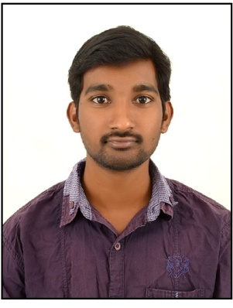
Qualification : M.Tech.

Experience : 3 years
- Worked as an Asst Professor from 4nd April 2015 to 4th Sep 2015 (5 months) in Prasad Engineering College.
- Worked as an Asst Professor from 23nd Nov 2015 to 25th July 2016 (9 months) in Christu Jyothi Institute of Technology and Sciences,
- Working as an Asst Professor from 16th Dec 2016 to till now in (1 Year 6 months) Vaagdevi College of Engineering.
Area of Interest : Structural Engineering,Design&Analysis.
Subjects Taught : Construction Technology & Project Management, Transportation Engineering, Prestressed Concrete Structures.

Workshops/Seminars/FDP’s Attended:
Workshop – 1
FDP – 1
- Attended a Two day Workshop on Pavement Design, Construction Management System.
- Attended FDP workshop on Auto Desk Revit conducted by ICT academy.

