Name: Bandi Krishna | 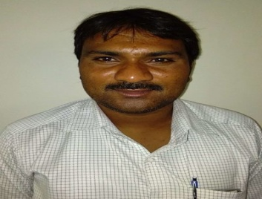
Qualification : MCA,M.Tech(Ph.D)

Experience: 10+ YEARS
Area of Interest: Data Mining, Information retrieval
Subjects Taught: CP, DSC++,Java Programming,Web Technologies,MAD,Software Engineering, MMAD,DBMS, SPM
Research Publications:(IEEE reference format)
05
Projects guided: 22
Workshops/Seminars/FDP’s Attended: 08

