Name:D. Naveen Kumar | 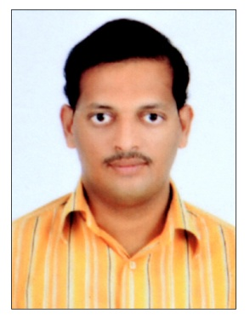
Qualification:M.Tech(JNTUH)(mention university name if reputed )

Experience:9 years
Area of Interest:Information security , Network security

Subjects Taught:
CP, Formal Languages and Automata Theory (FLAT), Design Patterns, Artificial Intelligence, Network Security, Operating system, Computer Networks, Advanced computer networks, Software Project Management, Software Engineering, Software Testing Methodologies

Research Publications:(IEEE reference format)

1. “ Invariant Character View Recognition in Artificial Neural Networks based on Pattern
Classification”, Global Journal of Computer Science and Information Technology (GJCSIT),
Vol. 1 (1), 2014, 33-37
2. “ALMP Routing in Wireless Networks”, International Journal of Systems , Algorithms &
Applications, Volume 2, Issue 8, August 2012, ISSN Online: 2277-2677.
3. “A Dual Framework for TargatedOnine Data Delivery Algorithms”, International Journal of
Computer Science and Information Technologies,Vol 5(2), 2014,1796-1799

Workshops/Seminars/FDP’s Attended:
- One Week Faculty Development Program on SOFT COMPUTING conducted by Dept of CSE Vaagdevi College of Engineering, Warangal, in association with CSI Chapter, Hyderabad during 19th to 24th June 2017.

- Twodays workshop on “Cloud computing ” at SRIIT,Hyderabad,2013

- Oneday FDP on “OUTCOMES- BASED RNGINEERING EDUCATION FOR ENHANCED EMPLOYABILITY ” at SR Engineering college, Warangal,2013.

- Two week FDP on “WIPRO MISSION 10X ” at SR Engineering college, Warangal,2012

- One week workshop on “C and Datastructures ” at SR Engineering college,Warangal,2012

- Fivedays workshop on “Advances in Computer Vision: From Foundations To Applications ” at Vignan University, Guntur, 2011.

Conferences Attended:

1. “Semantic Ranking Approach For Web Search Engines ”, International Conference On
Systemics, Cybernetics and Informatics.

