Name:DEEPIKA RANGARAJU | 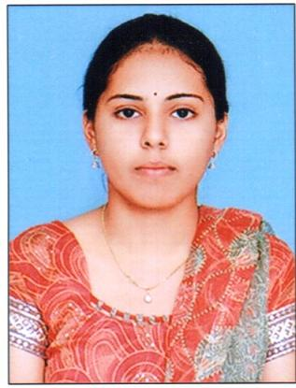
Qualification : MTECH JNTU HYDERABAD
Experience: 7
Area of Interest: CLOUD COMPUTING

Subjects Taught: DBMS,PPL,CO,NP
Research Publications:
[1] R.DEEPIKA,FARHA "THE PERFORMANCE ANALYSIS OF FUZZY EYWORD SEARCH OVER ENCRYPTED CLOUD DATA USING DIFFERENT SEARCHING SCHEMAS" VO1 1,ISSUE 2,2013 -GRET Journal

Projects guided:

Title | Student Name | Year
HUMAN RESOURCE MANAGEMENT SYSTEM | VENNALA | 2018

Workshops/Seminars/FDP’s Attended:
- Workshop on “ASTRAA2K16 – Cloud Computing” at Vaagdevi College of Engineering.
- ISTE-WORKSHOP on DATABASE MANAGEMENT SYSTEMS conducted by IIT, BOMBAY
- ISTE- WORKSHOP on “Aakash for Education “conducted by IIT, Bombay.
- Workshop on “Programming Technologies”, Nov, 2009.
- FDP on "Introduction to R-Programming" by ICT Academy,FEB 2018
- FDP on “SOFT COMPUTING” at Vaagdevi College of Engineering JUNE 2017.
- FDP on “MORALS AND ETHICS OF TEACHING” at Vaagdevi College of Engineering, MAY 2017.
- FDP on “Network Simulation using Qualnet software” with DELLSOFT TECHNOLOGIES Pvt. Ltd.
- FDP on “BACK TO BASICS” at Avanthi Group of Institutions, Hyderabad, JAN 2017.
- FDP on “Teaching Methodologies” Dec 2011, at BITS, Narsampet.
- FDP on “INTERNATIONAL YOUTH FELLOWSHIP” at JNTU Hyderabad.
- FDP ON “INTRODUCTION TO R-PROGRAMMING” BY ICT ACADEMY,FEB 2018

Conferences Attended:
- “International Conference on Computational Intelligence & Informatics”, 2016 at JNTUH
- “International Conference on Computer Science and Information Technology”, 2013.

