Name: DOPATHI HARITHA | 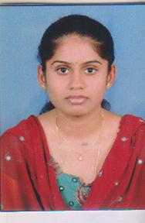
Qualification:
M.Tech(CSE)
B.tech(CSE)
.

Experience: 3 years
Area of Interest: Programming languages

Subjects Taught: DSC++, C
Workshops/Seminars/FDP’s Attended: Dellsoft Technologies,
FDP on Soft computing

