Name: Dhavaleshwar Rao.Bhandaru  Assistant Professor | 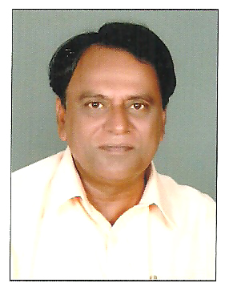
Qualification : M.Tech (Ph.D)

Experience (write a brief paragraph): 5 years 3 months
- Worked as an Asst Professor from 1st June 2012 to 31st Jan 2015 (2 years 7 months) in Ramappa Engineering College.
- Worked as an Asst Professor from 1st March 2015 to 31st Oct 2016 (1 year 2 months) in Vignana Bharathi College.
- Working as an Asst Professor from 16 Nov 2016 to till now in (1 Year 7 months) Vaagdevi College of Engineering.
Area of Interest: Construction, Teaching & Research
Subjects Taught: WRE- I & II, RRS, E&C, BMCP, Surveying.

Research Publications:(IEEE reference format)
- B.Dhavaleshwar, and RVRK Chalam (under process) Water logging in Godawari basin and suggesting Remedial methods.
Workshops/Seminars/FDP’s Organized:
- On the Occassion of Engineers Day.
Workshops/Seminars/FDP’s Attended:
- Presented ad Presented and published paper in National Seminar Conducted in the month of October 2013 by “NIT”-Warangal on “Irrigation Technologies of Kakatiyas”.
- Presented and published a paper in National seminar conducted in the month of December 2013 by KITS-Warangal on “Health Monitoring of L.T.Bayyaram”.
- Presented and published a paper Conducted in the month of July 2015 by JNTU-Hyderabad on “Preserve,Conserve and Utilize”.
- Presented and published a paper Conducted in the month of July 2016 by JNTU-Hyderabad on “”Solid Waste Leachate Recirculation” as Co-Author.
Conferences Attended:(preferably International)
Achievements:
- Honored by Kakatiya Technocrats Forum for dedicated services to the Department on the eve of Engineers day.
- Intiated Laying Foundation stones for Kineerasani & Budidavagu by Honourable Chief Minister of A.P on 31-12-2005.
- Appriciation by Enginner in Chief-for saving the Large Tank. Bayyaram during Heavy Floods form Breach. Recommended the name to the Government for Best Engineer Award.
- Three Articles were Published in News Papers.
- News Media conducted interviews regarding adoption of latest Technologies to be implemented in Irrigation.
- An article was selected for Publishing as Book By German Publishers.
- An article was published by Department of Tourism-Government of Telangana.
- 4(four) articles were Published in Different National Seminars.

