Name: Dr. MAHESH KANDAKATLA | 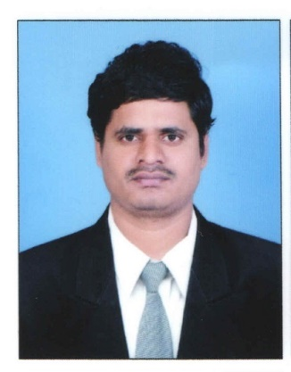
Qualification : M.Tech , Ph.D.

Experience: 9 YEARS
- Area of Interest: Data mining ,Machine Learning , Network security , Adhoc networks

- Subjects Taught: Data warehousing and datamining, Intellectual Property Rights , Web Technologies , Software Engineering , Operating Systems ,Information Technology for Managers

Programming Languages: C, C++,ADS, JAVA, J2ME, Scripting Languages

Research Publications:

Book Published:
- ” Cluster Analysis for Purpose Oriented Data Mining In Large Databases” ISBN-13: 978-620-2-09571-6 , ISBN-10: 6202095717, EAN: 9786202095716 in December 2017- LAP LAMBERT Academic Publishing.

Publication:
- “A REVIEW ON BANKING SECTOR” in International Journal of Engineering and Techniques - Volume 3 Issue 6, Nov - Dec 2017

- “Product Recommendation Using Social Media to E-Commerce with MicroBlogging: Cold Start” in International Journal of Research, November 2017

- “Optimal structure of web coding in Ad- Hoc organizations” in International Journal of Research, November 2016

- “Dynamic Framework for Protection of Location Services” in International Journal of Research, November 2016

- “Relative Parameter Quantification in Data Mining-A Case study on telecom cellular mobile service providers in terms of QOS in India” in International Journal of Data mining and Knowledge Management Process (IJDKP) September 2015.

- “A survey on cluster techniques for purpose oriented data mining” in INTERNATIONAL JOURNAL OF INNOVATIVE TECHNOLOGIES, JAN 2014.

- “rough sets based virus analysis of mobiles with bluetooth” in international conference “IT for real world problems” in the year of 2009.

Workshops/Seminars/FDP’s Attended:
- 3 day workshop on “Tizen” by Samsung R&D Institute India,2015
- 3 day workshop on “Network simulation using NS2” at JNTUH college of Engineering Jagitial,2014
- 2 day workshop on “Research opportunities in computer science and information technology” at CBIT Hyderabad,2013
- 2 day faculty workshop on “Data Mining Tools” at VCE Warangal in 2010.
- 2 day faculty workshop on “Neural Networks and EJB” at Vaagdevi College of Engineering” Warangal in 2009
- 1 week FDP on “softcomputing” at Vaagdevi college of Engineering Warangal ,2017
- 2 weeks FDP on Foundations of cryptography at NIT Warangal, 2016
- 1 Week FDP on IBM bluemix for IOT& Security at Jayamukhi institute of technological sciences, Warangal, 2016
- 1 week FDP on Data warehousing and business intelligence at NIT Warangal,2016
- 1 week Faculty Enablement program by Infosys campus connect at Padmasri BVRaju institute of Technology Hyderabad, 2010

Conferences Attended:(preferably International)
- Participated in the international conference on “ Information techonolgy for real word problems” at Vaagdevi college of engineering, 2009
Participated in the international conference VCon 10 organized by IEEE chapter and Vaagdevi college of engineering, 2010.
Achievements:
- Coordinator of M.Tech in Vaagdevi College of Engineering from 2016.
- Member of Board of Studies in Vaagdevi College of Engineering from 2016.
- Mentor for ministry of labor project in hackathon 1st & 2nd April 2017.
- In-charge to Vaagdevi Incubation Center.
- Team leader in WorldSpace India pvt. Ltd from December 2008 to May 2009.

