Name:G.Neelima | 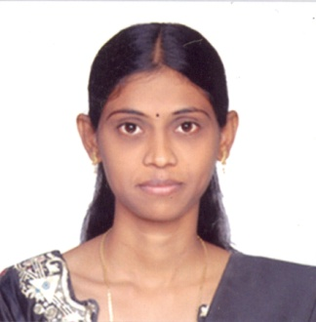
Qualification : M.Tech.
Experience: 9 Years
Area of Interest: Networking,programming
Subjects Taught: C,C++,Data Structures, JAVA,WT,AJT,CN
Research Publications:

1.Distributed Opportunistic Routing in wireless ad hoc networks.
2.An Efficient Intrusion Detection Scheme for Mitigating Nodes Using Data Aggregation in Delay Tolerant NetWork

Projects guided:

Title | Student Name | Year
COOPERATIVE RELAY TRANSMISSION IN MIMO AD HOC NETWORK | V.JYOTHIRMAI | 2014
DUPLICATE DETECTION IN HIERARCHICAL DATA BASED ON BAYESIAN NETWORK | REHANA BEGAM | 2014
AN ERROR-MINIMIZING FRAMEWORK FOR LOCALIZING JAMMERS IN WIRELESS NETWORKS | V.ASHOK | 2016
DISTRIBUTED OPPORTUNISTIC ROUTING IN WIRELESS AD HOC NETWORKS | SUSHMITHA.M | 2017

Workshops/Seminars/FDP’s Attended:
1. Astraa 2K15 a two day National Level Academic Enrichment Programme on “Mobile and Cloud Computing”.
2. 2nd vaagdevi international conference on An Introduction to Pattern Recognition and Applications.
3.2nd vaagdevi international conference on Modeling Malware Spreading: Aiming at a Moving Targer.
4. 2nd vaagdevi international conference on Information Technology for Real World Problems.
5. Astraa 2k10 a two-day national Level faculty development workshop on DATA MINING TOOLS.
6. ITFRWP`09 international Conference on Information Technology for Real World Problems.
7. Five Day Faculty Programme On “JAVA FUNDAMENTALS AND PROGRAMMING” organized by KITS, Warangal.
8.One Week Faculty Development Programme On “SOFT COMPUTING”organized by Vaagdevi college Of Engineering.
9. FDP program on MAD (Mobile application development ) organized by SR Engineering college.
10.Introduction to R-Programming organized by Vaagdevi college of engineering feb 5th 2018.
Conferences Attended:(preferably International)
1. 2nd vaagdevi international conference on An Introduction to Pattern Recognition and Applications.
2.2nd vaagdevi international conference on Modeling Malware Spreading: Aiming at a Moving Targer.
3. 2nd vaagdevi international conference on Information Technology for Real World Problems.
4. Astraa 2k10 a two-day national Level faculty development workshop on DATA MINING TOOLS.
5.ITFRWP`09 international Conference on Information Technology for Real World Problems.

