Name:JANGILI SWAPNA | 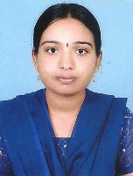
Qualification:M.tech -JNTUH,
B.Tech-JNTUH,
Intermediate-Board of Intermediate,
SSC-Board of Secondary School.

Experience:2years
Area of Interest: computer networks

Workshops/Seminars/FDP’s Attended:delsoft soft computing.

