Name: SHYAM LOKINI  Assistant Professor | 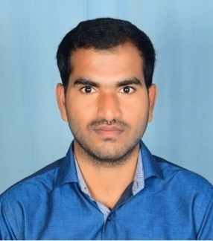
Qualification : M.Tech

Experience (write a brief paragraph): 2 year 6 months
- Worked as an Asst Professor from 5th Dec 2015 to 30th Nov 2016 (1 Year) Tudi Narsimhareddy Institute of Technology & Science.
- Working as an Asst Professor from 16th Jan 2017 to till now in (1 Year 6 months) Vaagdevi College of Engineering.
Area of Interest: Civil Engineering
Subjects Taught: Structural Analysis Building materials, construction& planning (BMCP).

Research Publications:(IEEE reference format) Nil
Grants: (if received any) Nil
Projects guided: Nil

UG projects
Title | Student Name | Year

PG projects
Title | Student Name | Year

Workshops/Seminars/FDP’s Organized: Nil

Workshops/Seminars/FDP’s Attended:
- Workshop on Auto Cad Construction & Management System
Conferences Attended:(preferably International) Nil
Achievements:
- Best employee award in Site(2015)

