Name: MAHOMAD RIYAZ | 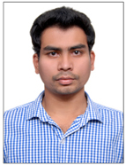
Qualification : M.Tech CSE
Experience: 1
Area of Interest: BIGDATA
Subjects Taught: C, CPP, OOPS,ITS,WT
Research Publications:

International Journals of Research (IJR)
On Data Mining for Big Data
Workshops/Seminars/FDP’s Attended:
- Eswecha_Workshop_2017
- One Week Program on Soft Computing.

