Name: MUSHAM SWETHA | 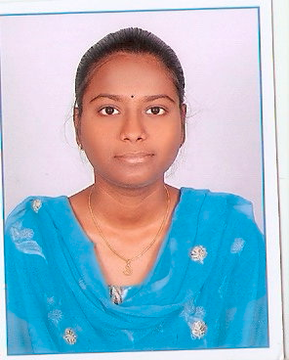
Qualification : M.tech -JNTUH,
B.Tech -JNTUH,
Intermediate- Board of Intermediate,
SSC-Board of Secondary School.

Experience:1years
Area of Interest: WEB TECHNOLOGIES

Workshops/Seminars/FDP’s Attended:delsoft soft computing.

