Name : Murali Krishna Vanam | 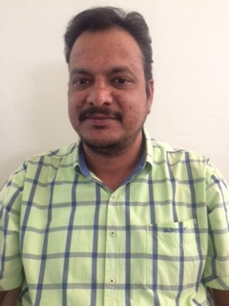
Qualification: | MS,Ph.d
Experience | 10 Years
Area of Interest | Biometrics
Subjects Thought | C,C++,Biometrics,Software Engineering,Software Project Management,Artificial Intelligence & MFCS.
Research Publication | 1)Vein Pattern Recognition Using ROI Extraction  2)A New Approach to Vein Pattern Authentication

