Name: Dodda Nagaraju  Assistant Professor | 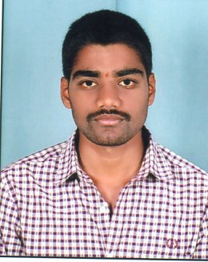
Qualification : M.Tech.

Experience : 6months
- Working as an Asst Professor from 06th Dec 2017 to till now in (6 months) Vaagdevi College of Engineering.
Area of Interest : Structural Engineering
Subjects Taught : Surveying Lab -I, Engineering Geology (Theory), Engineering Geology lab, Concrete Technology (Theory), Concrete Technology lab.
Research Publications:
- Dr. S Sunil Pratap Reddy, and Dodda Nagaraju, 05 June (2017), “An Experimental study on partial replacement of Coconut shell in coarse aggregate” in International Journal of Professional Engineering Studies, Volume8.
- Dr. S Sunil Pratap Reddy, and Dodda Nagaraju, 01 June (2017), “An Experimental study on partial replacement of Granite Powder in Fine aggregate” in International Journal of Reseasrch in Advanced Engineering Technologies, Volume6
Projects guided:

UG projects
Title | Student Name | Year
Calculation the area of viswambhara educational society by conventional method at bollikunta(2017) | P.Spandana,  B.Sandeep,  M.Tejasri,  M.Akhil,  G.Narender | 2017
An experimental study on partial replacement of fine aggregate with granite powder and coarse aggregate with coconut shell. (2017) | N.Rasaveena ,  B.Rajitha,  CH.Rajesh ,  R.Swayam Prakash,  K.kalyan | 2017
Calculation of design speed in vaagdevi college of engineering at bollikunta (2018) | S.Sai Krishna,  CH.Rajesh,  R.Swayam Prakash, B.Sandeep | 2018
An experimental study on strength characteristics of concrete by partial replacement of cement with marble powder (2018) | M.Ramesh ,  G.Ravinder,  Ramya | 2018
An experimental study on strength characteristics of concrete by partial replacement of cement with silica fume. (2018) | M.Srikanth,  A.Praveen Raju,  D.Pranith Reddy,  D.Sumanth | 2018

PG projects
Title | Student Name | Year

Workshops/Seminars/FDP’s Attended:
Workshop – 1
- A “Two day in Workshop on Pavement Design, Construction Management System” on Dec 15th and 16th 2017.

