Name |  |  | Qualification |  | Designation |  | Mail-id |  | Mobile#
Pokala Shailaja |  |  | M.TECH,PHD (PURSUING) |  | Assoc.prof |  | pokalashylaja@gmail.com |  | 9440645806
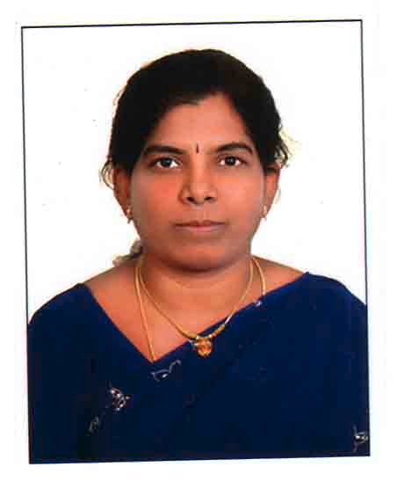 |  |  | Professinal Memberships  1)ASSOCIATE IN THE INSTITUTION OF ENGINEERS(INDIA)  2)LIFE MEMBER IN THE INDIAN SOCIETY FOR TECHNICAL EDUCATION.  Area of Interest:  1)Mobile Computing  2)Sensor Networks  Achievements:  Subjects taught:  3)Adhoc and Sensor networks  Mobile computing
Publications
- 1Maximizing P2P File Access Availability in Mobile Ad Hoc Networks through Replication for Efficient File Sharing.
- A Probabilistic approach for Detecting Node Failures in Mobile Wireless Networks
Workshops Attended
- An Introduction to Pattern Recognition and Applications December-2010 Vaagdevi college of Engineering.
- Information Techonolgy For Real World Problems. December-2009 Vaagdevi college of Engineering.
- ISOTFRWP-AUG-2008 Vaagdevi college of Engineering
- Latest Advances in Computer Technology 30-11-2004 Vaagdevi college of Engineering
- Data Mining ,Neural Networks Advanced Java Technologies and Effctive Teaching Methodolies Dec -2007 Vaagdevi college of Engineering
- Data mining,NET,UML,OODB and Socket Programming NOV-2006 Vaagdevi college of Engineering
- Advanced Unix Programming with Industrial Perpective Dec-2005 Vaagdevi college of Engineering
- MOBILE& CLOUD COMPUTING - 2016 Vaagdevi college of Engineering
FDP ‘s Attended
1. G. Pulla Redddy Memorial Lecture on Cloud Computing -Dr. M. Seetha -26th Oct,2017-organized by G.Narayanamma Institute of Technology and Science
2. FDP on Networking Simulation using Qualent Software, organized byMr. Rajesh Jha, 14th September, 2017, DELLSOFT Technologies

3) Microsoft &IEG FEB-2009 by MICROSOFT SYSTEMS
4) SOFT COMPUTING -2017 Vaagdevi college of Engineering
5) Moral and ETHICIS IN TEACHING METHODOLIGES JULY-2017 organized by Vaagdevi college of Engineering
6)SECURITY&PRIVACY organized by Electronics&ICT Academy ISEAP-April-2016 NIT WARANGAL
7)BUSINEANCE AND INTELLIGEANCE TECHNOLGY AND TOOLS organized by NIT WARANGAL-2005

.

