Name: D. Pruthvi Raj  Assistant Professor | 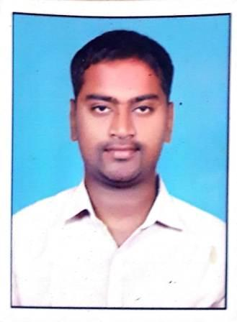
Qualification : M.Tech

Experience (write a brief paragraph): 4years
- Worked as an Asst Professor from 15 Aug 2012 to 11th Sep 2013 (1 years) in Aurora Research Technological and Institute ARTI
- Working as an Asst Professor from 7th Aug 2015 to till now in (2 Year 9 months) Vaagdevi College of Engineering.
Area of Interest: Transportation Engineering, Geomatics and RS&GIS
Subjects Taught: Transportation Engineering,Pavement Design,Airport Planning & Design,Building Material Constructions & Planning,Engineering Geology Transportation Engineering – I,Transportation Engineering – II,Fluid Mechanics,Hydraulics & Hydraulic Machinery,Hydrology

Research Publications:(IEEE reference format)
Grants: (if received any)
Projects guided:

UG projects
Title | Student Name | Year
Utilization of plasticized bitumen mix in construction of flexible pavement roads | (14641A0164, 14641A0176, 14641A0175, 14641A0179) | 2018
Strength characteristics of flyash concrete&trip generationWarangal district. | (14641A0170, 14641A0171, 14641A01B8, 14641A01A9) | 2018
Development of structural performance of cement concrete roads | (10871A0130, 10871A0101, 10871A0108) | 2018
A case study on existing core road network & proposed outer ring road warangal district | (14641A0137, 14641A0141, 14641A0138, 14641A0117, 14641A0153) | 2018

Workshops/Seminars/FDP’s Organized:
- A Workshop on ‘Pavement Design and Management Systems’
Workshops/Seminars/FDP’s Attended:
- Rheology Of Bituminous Binders, FDP @ IIT Madras
- Recent advances in construction materials , FDP
- Effective Teaching and Learning of flexible pavement design, FDP
- Evaluation of Transportation Projets, GIAN @ NIT Warangal
- Geospatial Data collection and analysis , FDP @ Osmania University

