Name: RAJITHA BONAGIRI | 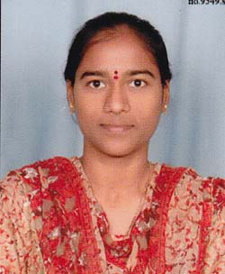
Qualification : M.Tech
Experience: 7years 8 months
Area of Interest: Big data
Subjects Taught: Data Structures Through C++,
Formal Languages And Automata Theory,
C Language,
Operating System,
Compiler Design
Research Publications:(IEEE reference format)
- International journal on “PPDP Strategies for Privacy Breaching Problems in Information Publication” , IJSETI , Volume No.03, Issue No.01, June-2014, ISSN 2348-2370.

- International journal on “Concerning a Numerical Structure for Expert Anonymity in Sensor Systems”¸ IJR, Volume number:3, Issue number:17, November 2016, p-ISSN: 2348-6848 ,e-ISSN: 2348-795X.
- International journal on “HLA Based Public Auditing Architecture for Wireless Ad hoc Networks”, IJIEMR, Volume number:01, Issue number:02, ISSN 2456-5083.
Workshops/Seminars/FDP’s Attended:
- A National Level Two-Day Workshop On “Mobile & Cloud Computing” held at Vaagdevi College of Engineering.
- Two-Day FDP on “Bigdata Analytics Using Hadoop & R-Tools” held at KITS, Warangal.

- Two Day FDP on “Network Programming And Wireless Networks” held at KITS, Warangal.

- Two Day FDP on “Morals And Ethics In Teaching Methodologies” held at Vaagdevi College of Engineering.

- One week FDP on “Soft Computing” held at Vaagdevi College of Engineering.

- Two Day FDP on “Emerging Trends in Data Mining and its Applications” held at KITS, Warangal.

- Two Day FDP on “Research Insights in Cloud and Bigdata” held at KITS, Warangal.

- A One Day FDP on “Network Simulation using Qualnet Software” with DellSoft private limited.
.

