Name:RAMA. Mamidala | 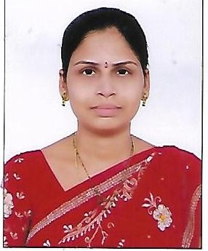
Qualification : M.Tech (JNTUH)

Experience: 10 years
Area of Interest: Programming

Subjects Taught: C ,C++, JAVA, NP
Workshops/Seminars/FDP’s Attended:
ISTE Workshop on DataBase Management Systems
Soft Computing
Sales Force Trailhead Developer Educator
3 days Work shop on R – programming (2018)

