Name: SUDDALA ADARSH  Assistant Professor | 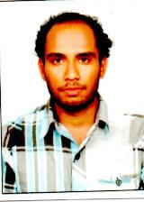
Qualification : M.Tech.

Experience : 1year 6months
- Working as an Asst Professor from 02nd Jan 2017 to till now in (1 Year 6 months) Vaagdevi College of Engineering.
Area of Interest : STRUCTURAL ANALYSIS,DRCS ,DSS, CT,E.E
Subjects Taught : CONCRETE TECHNOLOGY
Research Publications:
- MIX DESIGN OF COMPOSITE SOIL CONCRETE IN STRUCTURE AND ITS STRENGTH (IJPES)
Workshops/Seminars/FDP’s Organized: Nil
Workshops/Seminars/FDP’s Attended:
- WORKSHOP ON AUTO CAD, WORKSHOP ON PAVEMENT DESIGN, CONSTRUCTION & MANAGEMENT SYSTEM

