Name:SUPRIYA BARIGELA | 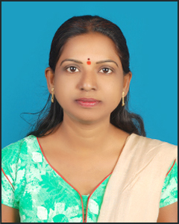
Qualification : M.tech -KITS, Warangal,
B.Tech -JNTUH,
Intermediate- Board of Intermediate,
SSC-Board of Secondary School.

Experience:1years
Area of Interest: Web Technologies, Java

Workshops/Seminars/FDP’s Attended:Delsoft ,Soft computing.

