Name: SWAPNA MANUPARTHI | 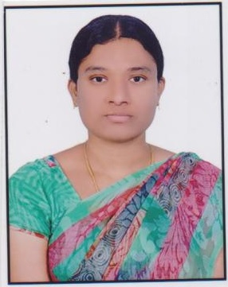
Qualification :M.Tech CSE

Experience: 7

Area of Interest:NETWORKING, PROGRAMMING IN C,C++, JAVA

Subjects Taught:JAVA,CN,OOAD,WT,AJT,C,C++,NS

Research Publications:
1, Designing High Performance Web Based Computing Services to Promote Tele Medicine Database Management System. IJIEMR. Vol 1, Issue 2. Impact factor: 5.812
2, Public Key Cipher Scheme For Rapid Keyword Search, IJIEMR. Vol - 01, Issue – 02 Oct 2016.

Projects guided:

Title | Student Name | Year
Event management system | V.Sneha | 2018
Online railway reservation system | Ch.Narmadha | 2018
Automated timetable generator | T.Sharanya | 2017
Public key cipher scheme for rapid keyword search | G.Harika | 2016
Designing high performance web based computing service to promote telemedicine database management system | V.Sahithi | 2016
Efficient correlation of security attack through stepping stones by flow watermarking | B.Sudharani | 2015
Retrieval of web forums using regular expression patterns | T.Mrunalini | 2015
Belligerent tackle hire classification | A.Aparna | 2015
Redundancy management in HWSN`s | B.Uma | 2014
Two tales of privacy in online social network | D.Ramakrishna | 2014
Smart inventory management system | A.Shirisha | 2013
Online book sales | A.Tayyaba | 2013

Workshops/Seminars/FDP’s Attended:
1, Information Technology for real world problems.

FDP’s Attended:
1, Data Mining, NEURAL Network, Advanced Java Technologies and Effective Teaching Methodologies.
2, Moral and Ethics of Teaching
3, Soft Computing
4, Mobile and Cloud Computing
5, Software Engineering and Testing Methodologies.
6, Networking Simulation using Qualent Software

Achievements:GATE QUALIFIED

