Name: SWETHA ARRA | 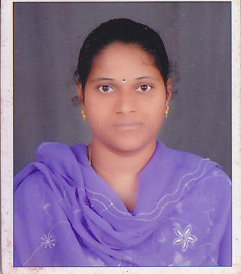
Qualification : M.TECH

Experience:11
Area of Interest:Network security

Subjects Taught:CG,CD,ACD,DBMS,MFCS,DWDM
Projects guided:1

Title | Student Name | Year
PIZZA Management system | Adithya | 2017-18

Workshops/Seminars/FDP’s Attended:
1. Participated in Faculty Development Workshop on Neural Networks and EJB conducted by Vaagdevi College of Engineering, Warangal.
2.Participated in ADVANCES COMPUTER TECHNOLOGY conducted by VAAGDEVI COLLEGE OF ENGINEERING. .
3.Attended Workshop conducted at vaagdevi college of Engineering on Data Mining ,.NET,UML,OODB and SOCKET Programming.
4.Workshop attended in ASTRA2K6 at Vaagdevi College Of Engineering .
5.Workshop attended in ASTRA2K7 at Vaagdevi College Of Engineering on WEKA TOOLS.
6.Workshop attended in ASTRA2K9 at Vaagdevi College Of Engineering on DATA MINING.
7.Workshop attended in ASTRA2K10 at Vaagdevi College Of Engineering .
8.Workshop attended at VaradhaReddy college of engineering on mobile computing.(2012)
9. Workshop attended at VaradhaReddy college of engineering onIRS.(2013).
10. Workshop attended in ASTRA2K16 at Vaagdevi College Of Engineering on Cloud Computing
11.FDP on “WEB TECHNOLOGIES” at JAYAMUKHI INSTITUTE OF TECHNOLOGICAL AND SCIENCES
12. FDP on “SOFT COMPUTING” at Vaagdevi College of Enigineering.
13.FDP on “MORALS AND ETHICS OF TEACHING” at Vaagdevi College of Enigineering.
14.FDP on NETWORK SIMULATION USING QUALNETsoftware with DELLSOFT TECH pvt .ltd

Conferences Attended:
1 Participated International Conference on Information Technology for Real World Problems (VCON’10) held at Vaagdevi College of Engineering, Warangal.
1 Participated International Conference on Information Technology for Real World Problems (ITFRWP’09) held at Vaagdevi College of Engineering, Warangal.

