Name: Asaboyina Sravanthi  Assistant Professor | 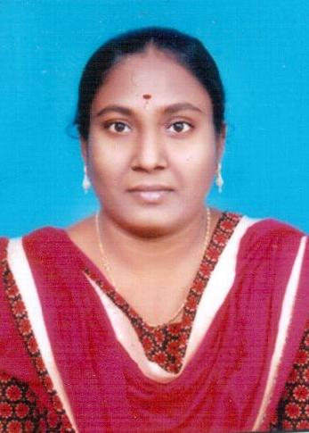
Qualification : M.Tech

Experience (write a brief paragraph): 1 year 06 months
- Working as an Asst Professor from 2nd Jan 2017 to till now in (1 Year 6 months) Vaagdevi College of Engineering.
Area of Interest: Civil Engineering, Structural Engineering,Geo-technical Engineering.
Subjects Taught: Strength of Materials-II, Geo-Technical Engineering, Foundation Engineering, Concrete Technology, Estimation & Costing.
Research Publications:(IEEE reference format)
- Asaboyina Sravanthi, (2016) “Experimental Investigations on Thermally treated Alumino silicates in concrete.” In International journal of research, Volume-03, issue-14 october 2016, ISSN:2348-6848
Projects guided:

UG projects
Title | Student Name | Year
Estimation of field channels | K.Nagesh Reddy, MD.Hameed, B.Chowhan, B.Suresh | 2018
Construction of under Tunnels | B.Mounika, T.Sravanthi. B.Rajitha, B.Vinod | 2018
Comparative Study On Effect of Burnt Brick Dust and Woven Geotextile Material on Black Cotton soil | CH.Mounika, CH.Vinay, G.Sreekar, G.Thirupathi | 2018
Design of 100KL Over Head Balancing Reserviour | V.Ravalika, K.sai kumar, T.Neha singh, K.Sai kiran, B.Sathya sreeja | 2018
Experimental Study on Effect Of Burnt Brick Dust and Woven Geotextile material on Black cotton Soil | [K.Goutham, T.Sai Yadav, K.Arun, MD.Riyaz | 2018

PG projects
Title | Student Name | Year

Workshops/Seminars/FDP’s Organized:

Workshops/Seminars/FDP’s Attended:
- Participated in “Two day workshop on Pavement design, Construction and management systems”, on Dec 15th and 16th 2017
- Participated in “Three days Training programme on Geospatial Technologies” on march 28th and march 30th 2018.

