Name: SUNDER LAL BANATH  Assistant Professor | 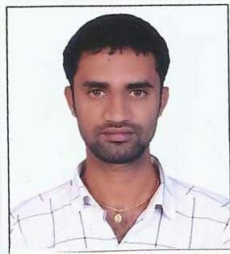
Qualification : M.Tech

Experience (write a brief paragraph): 2 year 3 months
- Worked as an Asst Professor from 7th March 2016 to 31 Dec 2016 (9 months) Vijaya Engineering College.
- Working as an Asst Professor from 15th Jan 2017 to till now in (1 Year 6 months) Vaagdevi College of Engineering.
Area of Interest: Civil Engineering
Subjects Taught: Surveying,Building materials, construction& planning (BMCP).
Workshops/Seminars/FDP’s Organized: Nil

Workshops/Seminars/FDP’s Attended:
- Work shop on Auto Cad.

