Name: THANVEER JAHAN | 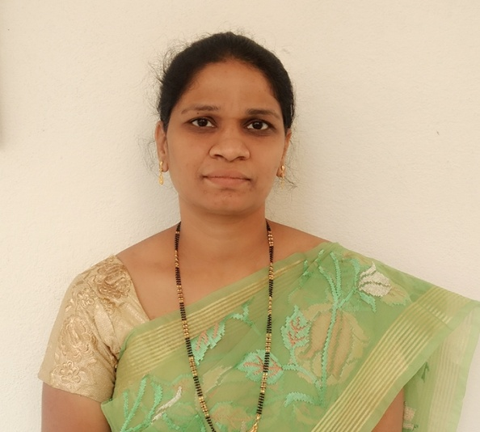
Qualification : PH.D (JNTU,HYD),M.TECH
Experience: 13 YEARS
Area of Interest: Data mining, Big Data, Security, Neural Networks.

Subjects Taught: Data Structures through C++, C, ADBMS, DBMS, Distributed Databases, Information Security, Network Programming, Data Communications, Advance UNIX Programming
Research Publications:

BOOK PUBLICATION
Thanveer Jahan, Dr G. Narsimha and Dr. C.V. Guru Rao, “A Multiplicative Data Perturbation”, published by Lambert Academic Publishing in Nov, 2016, ISSN 978-3-659-97067-2.

BOOK CHAPTERS
- Thanveer Jahan, Dr G. Narsimha and Dr. C.V. Guru Rao, “A Comparative Study of Data Perturbation Using Fuzzy Logic to Preserve Privacy”, Chapter – 13, Lecture Notes in Electrical Engineering 284, © Springer International Publishing Switzerland, 2013, DOI: 10.1007/ 978-3- 319 – 03692 - 2_13, ISSN 1876-1100, ISBN 978-3-319-03691-5, pp: 161-169.

- Thanveer Jahan, Dr G. Narsimha and Dr. C.V. Guru Rao, “A Data Perturbation Method to Preserve Privacy using Fuzzy Rules”, Accepted for publication in the text book on “Fuzzy Control Systems”, INTECH Open Science/ Janeza Trdine 9/51000 Rijeka, Croatia -EU, ISBN 978-953-51-5391-7.

INTERNATIONAL JOURNALS

- Thanveer Jahan, Dr G.Narsimha and Dr C.V.Guru Rao, “Privacy Preserving Clustering on Distorted Data”, In International Organization of Scientific Research, Journal of Computer Engineering, ISSN: 2278-0661, ISBN: 2278-8727 Vol 5, Issue No 2, pp: 25-29, Impact Factor: 1.213, Sep-Oct. 2012.

- Thanveer Jahan, Dr G.Narsimha and Dr C.V.Guru Rao, “A Hybrid Data Perturbation Approach To Preserve Privacy”, In International Journal of Scientific & Engineering Research, Vol 6, Issue No 6, ISSN: 2229-5518, pp:1528-1530, Impact Factor 3.8, June-2015.

- Thanveer Jahan, Dr G.Narsimha and Dr C.V.Guru Rao, “A Multiplicative Data Perturbation Method to Prevent Attacks in Privacy Preserving Data Mining” In International Journal of Computer Science and Innovation Infinity Sciences, Vol 1, Issue No 1, ISSN: 2458 6528, pp: 45-51, Impact Factor 2.8, March-2016.

- Thanveer Jahan, Dr G. Narsimha and Dr C.V. Guru Rao, “A Study of Data Perturbation Techniques in Privacy Preserving Data Mining”, In Proceedings of First International Conference on Computational Intelligence & Informatics (ICCII 2016) held at JNTU, Hyderabad, India during May 28-30th, 2016, ISSN 2229-3515.

- Thanveer Jahan, Dr G. Narsimha and Dr C.V. Guru Rao, “Novel Hybrid Geometric Data Perturbation By Means of Sampling Data Intervals”, communicated to Journal of Computational Science, ISSN 1877-7503.

Projects guided:

Title | Student Name | Year
Online Health Club to detect Heart diseases | S. Surya (14641A0564)  K. Dharanidhar Reddy (14641A0591)  N. Ramu (14641A0570)  B. Srikesh | 2018
Music Catalog | S. Surya (14641A0564)  K. Dharanidhar Reddy (14641A0591)  N. Ramu (14641A0570)  B. Srikesh | 2018
Online Gadget Maker with various Configuration | Ramanujam Gurrapu Venkata Krishna | 2017
Online Student Grade System | D.SINDHUJA (13UK1A0531)  K.TEJASWI (13UK1A0512)  A.SHANTHI (13UK1A0542) | 2017

Workshops/Seminars/FDP’s Attended:
- Attended one week national workshop on “Big Data Analytics” at JNTU, Jagityal during 14-20th Dec-2015.
- Attended two day workshop on “Data Mining Tools” at VCE, Wgl during 26-27th Dec-2010.
- Participated in Two week MHRD workshop on “An Advanced Technology Programme (Research Oriented) on Network Programming & Security at NIT, Wgl during 9-21st June-2008.
- Attended One day workshop on “E-Commerce, Network Security & Legal Implications” at JITs, Wgl during 15 Dec-2007.
- Attended a Two day workshop on “Data Mining,.Net,UML, & Socket Programming” at VCE,Wgl during 24-25th Nov-2006.
- Attended One day workshop on “Advanced Unix Programming with Industry Prespective” at VCE,Wgl during 17th Dec-2005.
- Attended One day Workshop on “Latest Advances in Computer Technology”at VCE, Wgl during 30th Nov-2004.
Conferences Attended:

- Thanveer Jahan, Dr G. Narsimha and Dr C.V. Guru Rao, “Data Perturbation and Feature selection in Preserving Privacy”, In Proceedings of the 2012 Ninth International conference in Wireless and Optical Communication Networks (WOCN2012), held at Indore Radisson Blu, Indore, Madhya Pradesh, India, during September 20-22, 2012, DOI: 10.1109/WOCN.2012.6335531, ISBN 978-1-4673-1989/12, pp: 1-6.

- Thanveer Jahan, Dr G. Narsimha and Dr C.V. Guru Rao, “Data Perturbation Using Fuzzy Logic To Preserve Privacy”, In Proceedings of International Conference on Recent Trends in Communications and Networks (COMNET2013), held at Hyderabad, Telangana, India during Nov 08-09, 2013, IET digital library, ACEEE, DOI: 10.1049/cp.2013.2622, pp: 415-419.

- Thanveer Jahan, Dr G. Narsimha and Dr C.V. Guru Rao, “A Comparative Study of Data Perturbation Using Fuzzy Logic to Preserve Privacy”, In Proceedings of Fifth International Conference on Networks & Communications (NETCOM2013) held at JP Hotel, Chennai, India during December 27-29, 2013, ISSN 1876-1100, ISBN 978-3-319-03691-5,DOI:10.1007/978-3-319-03692-2_13,pp:161 -169.

- Thanveer Jahan, Dr G. Narsimha and Dr C.V. Guru Rao, “Multiplicative Data Perturbation Using Fuzzy Logic in Preserving Privacy”, In proceedings of Second International Conference on Information and Communication For Competitive Strategies (ICTCS-2016) held at Hotel Inder Residency and Pacific University, Udaipur, Rajasthan, India, March 04-05, 2016, ISBN 978-1-450339629/16/03, DOI: http://dx.doi.org/10.1145/2905055.2905096.k

- Thanveer Jahan, Dr G. Narsimha and Dr C.V. Guru Rao, “A Study of Data Perturbation Techniques in Privacy Preserving Data Mining”, In Proceedings of First International Conference on Computational Intelligence & Informatics (ICCII 2016) held at JNTU, Hyderabad, India during May 28-30th, 2016, ISSN 2229-3515.

Achievements: Awarded with Ph.D from JNTU, Hyderabad.

