Name: Gangadari vishalkumar  Assistant Professor | 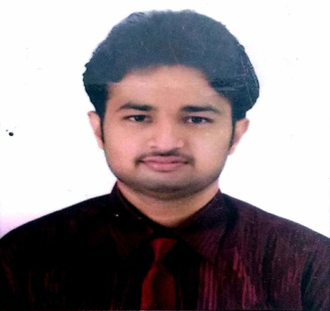
Qualification : M.Tech

Experience (write a brief paragraph): 1 Year 6 months
- Working as an Asst Professor from 2nd Jan 2017 to till now in (1 Year 6 months) Vaagdevi College of Engineering.
Area of Interest: Structures
Subjects Taught: Strength of material- lab, Irrigation, Fm & Hm Lab.
Workshops/Seminars/FDP’s Attended:
- A Workshop on ‘Pavement Design and Management Systems’
- Attended Autodesk Revit Architecture for 5 days.

