Name: Parsa Bhavana  Assistant Professor | 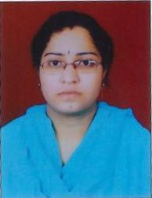
Qualification : M.Tech.

Experience : 6months
- Working as an Asst Professor from 23rd Dec 2017 to till now in (6 months) Vaagdevi College of Engineering.
Area of Interest : Transporation Engineering
Subjects Taught : Highway Engineering, Transportation Engineering-II, Construction Technology and Project Mangement.

Research Publications:
- P. Bhavana, and Syed Viqar Malik (2018) Design aspects of Flexible Pavements and Quality management ( IJAMTES ).
- P. Bhavana, and Manikanta (2016) Analysis and Exicution of Road Work on NH-05 (IJR).
Projects guided:

UG projects
Title | Student Name | Year
Design and construction of Road from kalleda to miryala gunta thana. | Ganesh Reddy,  Sadhana,  Sandher ali,  Sohail | 2018
Design of Anicut | Vivek,  Amulya,  Ashakumari,  Roja. | 2018
Influence of Replacement of fine aggregate with copper slag in concrete. | Abilash,  Shashank,  Harish,  Akhil. | 2018
Estimation of national highway. | Rajesh,  Sujith,  Akilesh. | 2018
Design and construction of Road. | Sai Krishna,  Nikitha,  Tejaswini. | 2018

PG projects
Title | Student Name | Year

Workshops/Seminars/FDP’s Attended:
Workshop – 1
- A Two day in Workshop on Pavement Design, Construction Management System

