Name: Marapally Nireesha  Assistant Professor | 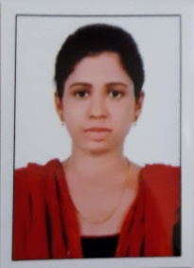
Qualification : M.Tech

Experience (write a brief paragraph): 1year 6 months
- Working as an Asst Professor from 2nd Jan 2017 to till now in (1 Year 6 months) Vaagdevi College of Engineering.
Area of Interest: Structures
Subjects Taught: Concrete technology, Design of steel structures.
Research Publications:(IEEE reference format)
- Dr. S. Sunil Pratap Reddy, and M. Nireesha (2016) An Experimental Study on the Effect of Chemical admixtures on Concrete with various cements, IJSETR (ISSN 2319-8885)
Projects guided:

UG projects
Title | Student Name | Year
A Study on permeable interlocking concrete pavements with emphasis on successful design and water quality benefits. | K.Kalyan(15645A0122),  J.Hemanth Kumar(1564A0123),  G.Dinesh Verma(14641A01A4)  K.Madan(14641A01A6). | 2017
Design and Estimation of Govt.Jr College | P.Ashok(14641A01E3),  A.Sai Madhav(14641A01E4),  J.Ranjith(14641A01F5),  G.Akhil(14641A01H7). | 2018
Combined effects of steel and glass fibre in standard grade concrete. | V.Kiran(14UK1A0165),  G.Anusha(15UK5A0115),  S.Mounika(14UK1A01B1),  R.Anvesh(14UK1A0195),  P.Rakesh(14UK1A0160). | 2018

PG projects
Title | Student Name | Year

Workshops/Seminars/FDP’s Attended:
- Actively Participated in Workshop on Pavement Design, Construction Management System.
- Autodesk Rivet Architecture for 5 days
Conferences Attended:(preferably International)
- An Experimental Study on the effect of Chemical Admixtures on concrete with various cements.

