Name: Shetty Radhika  Assistant Professor | 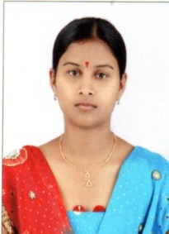
Qualification : M.Tech

Experience (write a brief paragraph): 1year 06 months
- Working as an Asst Professor from 18th Jan 2017 to till now in (1 Year 6 months) Vaagdevi College of Engineering.
Area of Interest: Structural Analysis
Subjects Taught: Surveying Lab II

Research Publications:(IEEE reference format)
- S.Radhika, and Ankush Jain (2016) Buckling and Vibration Anaysis of Cracked Composite Beam IJSRD (ISSN:2321-0613)
Workshops/Seminars/FDP’s Organized:
Workshops/Seminars/FDP’s Attended:
- Actively Participated in Workshop on Pavement Design, Construction Management System.

