Name: Vankdothu Sridevi  Assistant Professor | 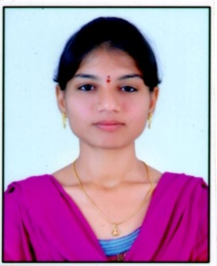
Qualification : M.Tech

Experience (write a brief paragraph): 1year 06 months
- Working as an Asst Professor from 2nd Jan 2017 to till now in (1 Year 6 months) Vaagdevi College of Engineering.
Area of Interest: Structures
Subjects Taught: Construction Management.
Research Publications:(IEEE reference format)
- Dr. Sunil Pratap Reddy, and V. Sridevi (2016) Regular and Vertical setback RC frame buildings subjected to seismic fragility analysis, IJSETR (ISSN:2319-8885).
Projects guided:

UG projects
Title | Student Name | Year
Under Tunnel. | K.Manivarma(14UK5A0102), T.Pravalika(15UK5A0112),  MD.Zeeshan(14UK1A0101), MD.Wasim Nayar(14UK1A0122). | 2018
Design of High Level Bridge. | Divya rani(15645A0104), Sammaiah(15645A0103), Pranay Kumar(14641A0152). | 2018

PG projects
Title | Student Name | Year

Workshops/Seminars/FDP’s Organized:
Workshops/Seminars/FDP’s Attended:
- Actively Participated in Workshop on Pavement Design, Construction Management System.
- Autodesk Revit Architecture for 5 days.

