Name of the Faculty & Photo | MIRZA UMAIRULLA BAIG  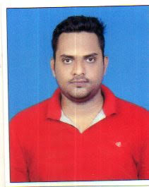
Designation | asst prof
Qualification | mtech
Specilization
Total Experience | Teaching (Years) | Industry (Years) |  | Research (Years)
 | 3years
Research Areas
Contact Details & mail ID | Mobile No : 9908157862  Email id : mirzaumair030@gmail.com
Subjects Taught | dsp wmc edc
Projects guided | UG | PG |  | PhD
Publications | Journals |  | Conferences
Publications List
Any other

