Name: Eeda Vikram  Assistant Professor | 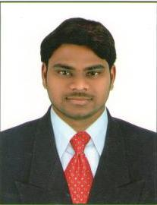
Qualification : M.Tech

Experience (write a brief paragraph): 1year 4 months
- Working as an Asst Professor from 24 Feb 2017 to till now in (1 Year 4 months) Vaagdevi College of Engineering.
Area of Interest: Structres, Construction Materials.
Subjects Taught: BMCP, Strength of Materials-I & II, Structural Analysis I, Design of Reinforced Concrete Structures

Projects guided:

UG projects
Title | Student Name | Year
Foundation Designe of High Rise Buildings in Water Logged Soils. | D.Avinash - 14641A0111 N.Nikhil - 14641A0146 P.Arun Kumar - 14641A0121 D.Rahul -14641A0107 | 2018
Effect of Earthquakes and Wind Loads on Residential Buildings by E-Tabs | Ashritha Ram basani - 14641A0128, Tharun Bikkala  - 14641A0118, Mohammed Furquan Baig - 14641A0117  Mohammed Nabeel Ahmed - 14641A0153 | 2018
Effect on Nano-Silica on the Strength of Selef Compacting Concrete | Mohammed Sohail -14641A0104, Jampala Saiteja -14641A0138, Pindi Sandeep Yadav-14641A0151,  Kounjula Rahul-14641A0157 | 2018

