Name: Potharaboyena Vinay  Assistant Professor | 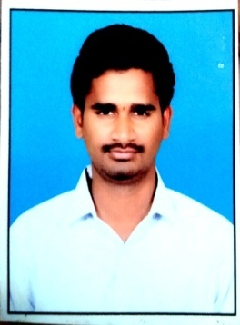
Qualification : M.Tech

Experience (write a brief paragraph): 1 year 06 months
- Working as an Asst Professor from 7th Jan 2017 to till now in (1 Year 5 months) Vaagdevi College of Engineering.
Area of Interest: Structural Engineering
Subjects Taught: Watershed Management, Engineering Geology, Environmental Engineering (Laboratory)
Research Publications:(IEEE reference format)
- P. Viany, and K. Srilaxmi, (2018), “Structural Anaysis and Design of Structural Elements of A Building in International Journal of Trend In Sceintific Research and Development (IJTSRD), Volume 2, Issue 3, March-April 2018, Pg no.:1132-1151
Projects guided:

UG projects
Title | Student Name | Year
Plan And Estimation of Government Junior College In Hanamkonda | B.Sri Priya, K.Abhishek, K.Ranjith Kumar, B.Shiva Prasad. | 2018
Formation of Bunds. Across Minor irrigation tanks Situated At Nagaram | M.Ruchitha, D.Sahaja, M.Meghana, B.Lavanya | 2018
Proposed Construction of Community Hall | B.Samatha, J.Kalyani, B.Venu, S.Raj Kumar, B.Vinay | 2018
Case Study on Mission Kakatiya | G.Shiva Krishna, L.Sandya Rani, L.Praveen Reddy, M.D.Sajeed Hussain, M.K.Saifuddin. | 2018

PG projects
Title | Student Name | Year

Workshops/Seminars/FDP’s Organized:

Workshops/Seminars/FDP’s Attended:
- Actively Participated “Two Day Workshop on Pavement Design, Construction Management System” on Dec 15th and 16th 2017
- A Five Day FDP Programme on Auto Desk Revit.

