VAAGDEVI COLLGE OF ENGINEERING
A U T O N O M O U S
P.O.BOLLIKUNTA, WARANGAL – 506 005
DEPARTMENT OF COMPUTER SCIENCE AND ENGINEERING

Summary Report 2021-2022

Computer Society of India

S.No | Academic Year | Workshops Organised | Date | Name of the Event | Participants
1  2 | 2021-2022  2021-2022 | 1  1 | 29-12-2021  30-12-2021 | Inaugural event of CSI- Student branch  IOT Session | 176  180
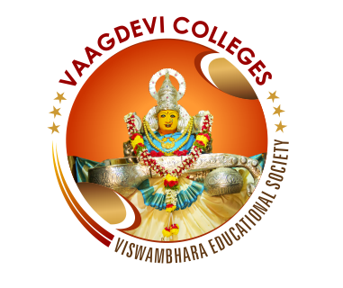
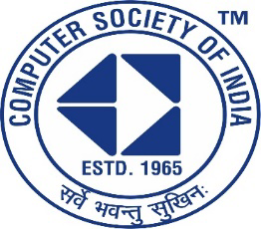

Vaagdevi College of Engineering
UGC-Autonomous
Computer Science & Engineering

Report on Inaugural of CSI

Title of event: Inaugural of Computer Society Of India student branch.
Date of event: 29th and 30th December 2021.
Convener: Dr.N. Satyavathi HOD, CSE.
Coordinators: M. Shirisha (Asst prof, Dept of CSE).
G. Neelima (Asst prof, Dept of CSE).
Organizers: Department of Computer Science of Engineering .
No. of students participated: 150+ students.
Sponsored by: Vaagdevi college of Engineering.

Objectives:
1) To be a part of the distinguished fraternity of famous IT industry leaders, brilliant scientists and dedicated academicians through networking.
2) Professional Development at Individual level.
3) Training and Certification in futuristic areas.
4) International Competitions and association with international bodies like IFIP and SEARCC.
5) Career Support.
6) CSI Awards and many more.

Brochure & links used for the event :
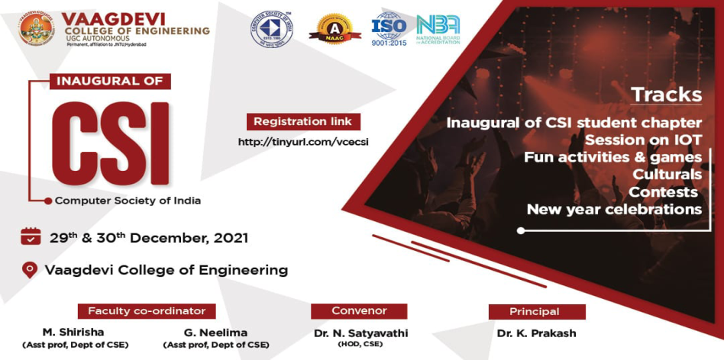https://forms.gle/KbnahDhFcBUAxg188 - Nominations for execom
http://tinyurl.com/vcecsi - Registration link for non-CSI members
https://forms.gle/7TbRt47RW8uCg1Gw6 - Culturals

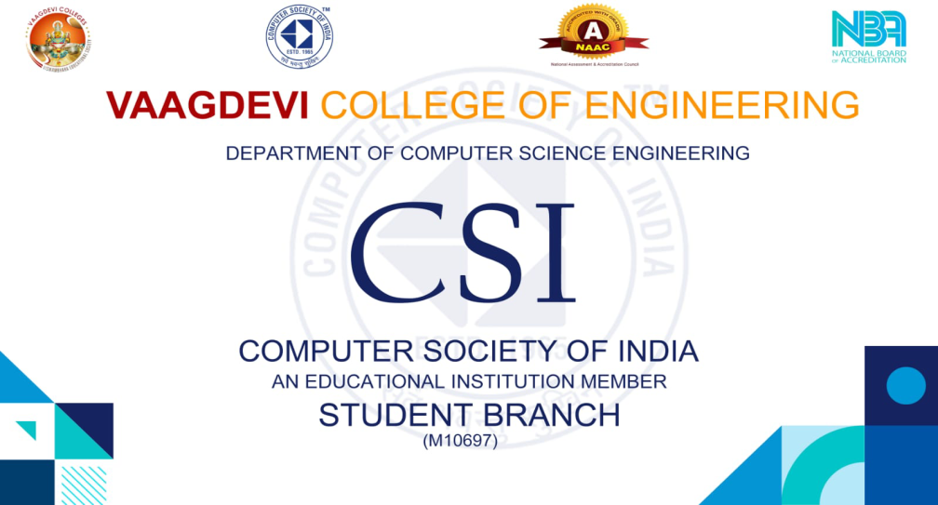
Official poster of Computer Society Of India for Inaugural.
On 29th December
CSI inauguration conducted at B block seminar hall
It was a wonderful event with 150 and above Students. The honourable guests are invited on to the stage and pleasant start with Jyothi prajwalana. Guests graced us with their valuable words on CSI. CSI student chapter was successfully inaugurated with a grand opening of poster. Student barriers are presented with the badges, with respect to their positions.
Vote of thanks was given by Chair person.
After lunch break
P. Rajkumar sir took a webinar on IOT

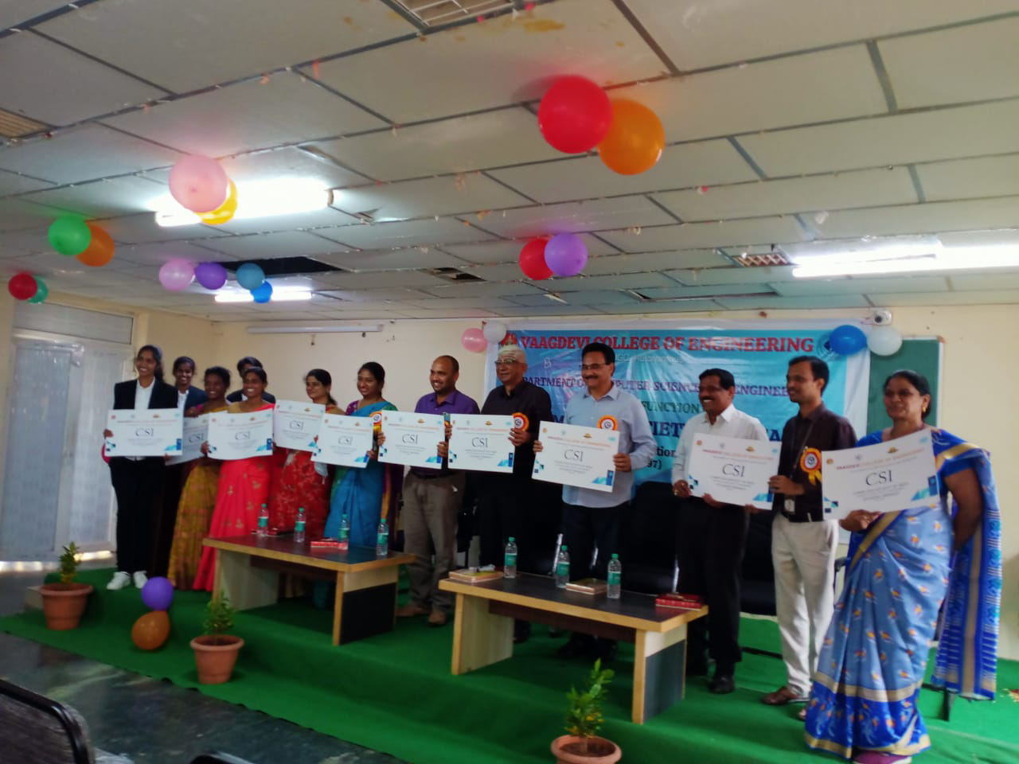
Poster releasing during the inaugural event.

On 30th December
- Session on IOT continued for the whole day. Students were fully involved in the subject that the queries session alone took more than an hour in the end.
- Fun activities in the middle of the session made it more enjoyable and interesting.
- A day of knowledge came to an end with the words of convener CSI.
-> Last but not the least, the whole program was a grand success with complete support of Satyavathi mam convenor of CSI, M. Shirisha mam, G. Neelima mam coordinators for CSI and all of our CSI VOLUNTEERS

*THANK YOU*

