VAAGDEVI COLLGE OF ENGINEERING
A U T O N O M O U S
P.O.BOLLIKUNTA, WARANGAL – 506 005
DEPARTMENT OF COMPUTER SCIENCE AND ENGINEERING

List of events conducted in the year 2022-2023

Computer Society of India

S.No | Academic Year | Workshops Organised | Date | Name of the Event | Participants
1 | 2022-2023 | 3 | 04-07-2022 | Webathon-Design a Creative Website | 32
2 |  |  | 02-09-2022 | Industrial Tour (Infosys campus visit) | 100
3 |  |  | 21-12-2022 | Awareness program for 2year students | 240

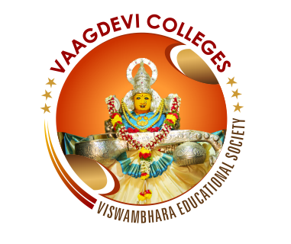
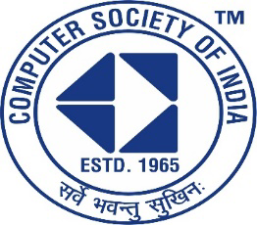

Vaagdevi College of Engineering
UGC-Autonomous
Computer Science & Engineering

Code Thinkerz Club
Title of event: Webathon-Design a Creative Website
Date of event: 4th July 2022.
Convener: Dr.N. Satyavathi HOD, CSE.
Coordinators: Dr.E.Balakrishna (Asst prof, Dept of CSE).
G. Neelima (Asst prof, Dept of CSE).
Organizers: Department of Computer Science of Engineering .
No. of students participated: 32 students.
Sponsored by: Vaagdevi college of Engineering.
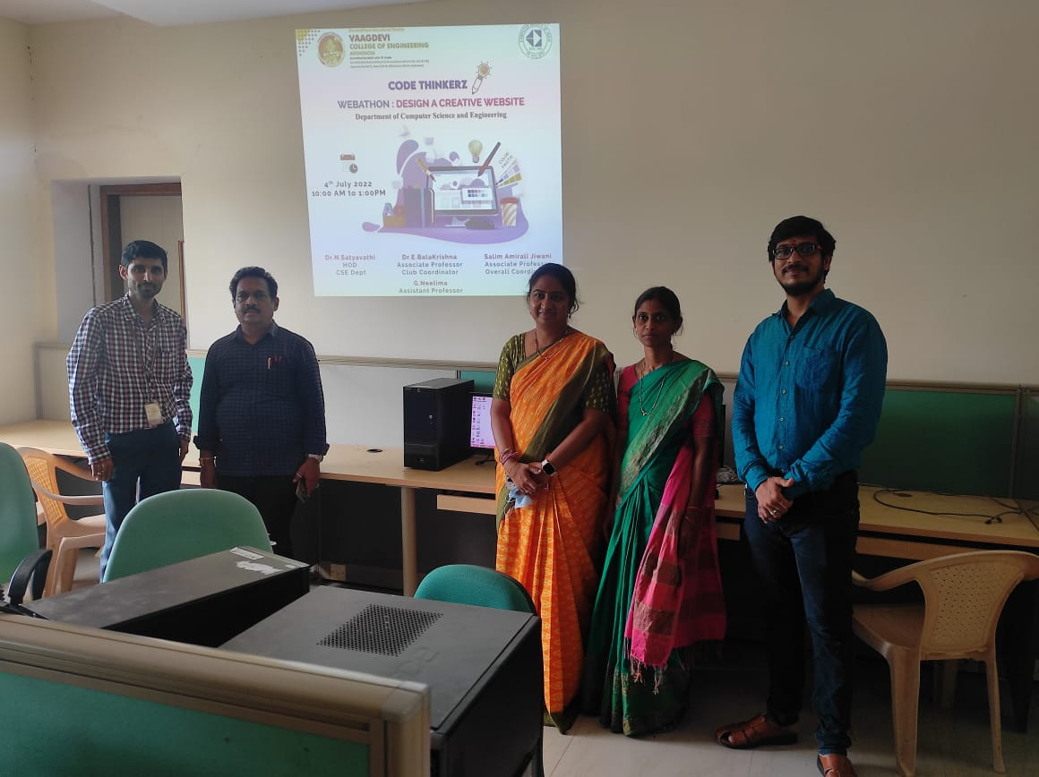

INDUSTRIAL VISIT AT INFOSYS SEZ, POCHARAM
CAMPUS, HYDERABAD

PURPOSE
Industrial visit to Infosys company at Pocharam, Hyderabad with 100 members and 4 faculties.
SCHEDULE
2nd September 2022
PARTICIPANTS
100
CO-ORDINATORS
M.Shirisha, G.Neelima
SUPPORTING FACULTIES
College TPO: Barkat Jiwani
Dept TPO: K.Shekar
SOURCE OF INCOME
Collected from students.
EXPENDITURE
60000/-
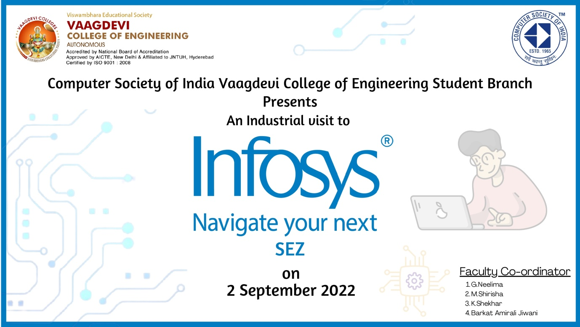
About CAMPUS VISIT

Training and Placement cell of CSI organized an Industrial visit at Infosys, Pocharam, Hyderabad on 2nd September 2022 for B.Tech 3rd year students.

Total 100 students participated in this event. The objective of this visit was to make the students aware about the company requirements and the work space of IT companies. Students should get knowledge about work culture of IT industry, Infrastructure and campus facilities provided by company.
From past years the team of Infosys conducted many days skill development program for all students and hence this visit is also a part of student connect program. This industrial visit organized in association with Infosys.
During this visit the HR team conducted a two hour session for all the students on various aspects of company requirements and career related issues of the students.

All the students and faculty members visited different location of Infosys like employee working area, Food Courts etc. The overall infrastructure was just exceptionally beautiful.
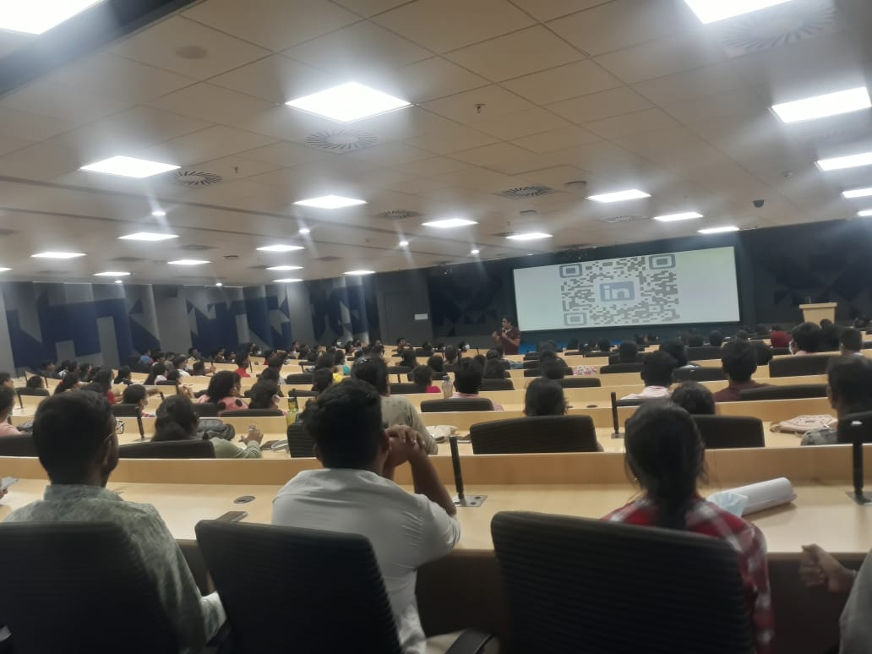

After visiting Infosys, students and faculties had a great lunch in the afternoon. And then a guide is appointed to us and he explained the total infrastructure of the Infosys company. As a part of its drive to become carbon neutral, Infosys is designing this campus on best-in-class sustainability principles to achieve energy efficiency, water sustainability, preservation and promotion of biodiversity and effective waste management.
Thank you

Vaagdevi College of Engineering
UGC-Autonomous
Computer Science & Engineering

CSI Awareness program
Title of event: CSI Awareness program and Membership Drive for 2nd year students
Date of event: 21st December 2022.
Convener: Dr.N. Satyavathi HOD, CSE.
Coordinators: M.Shirisha (Asst prof, Dept of CSE).
G. Neelima (Asst prof, Dept of CSE).
Event Organizers: Execom Members, CSI Student volunteers
- Pranay (Team Lead)
- Ramana kumar (Chairman)
Organizers: Department of Computer Science of Engineering .
No. of students participated: 240 students.
Sponsored by: Vaagdevi college of Engineering.
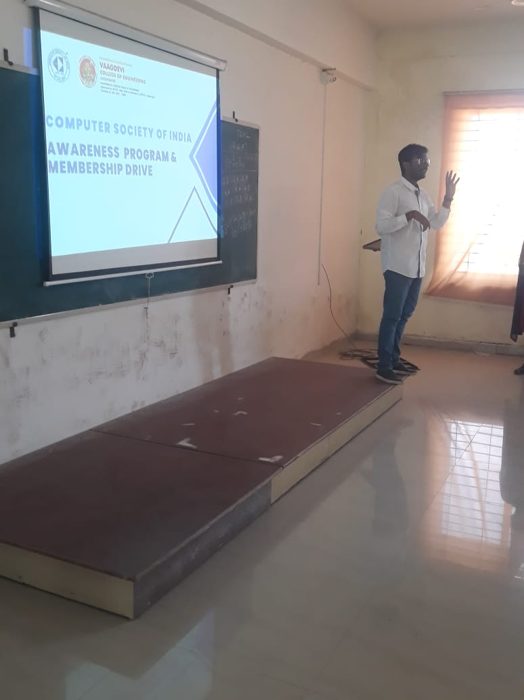

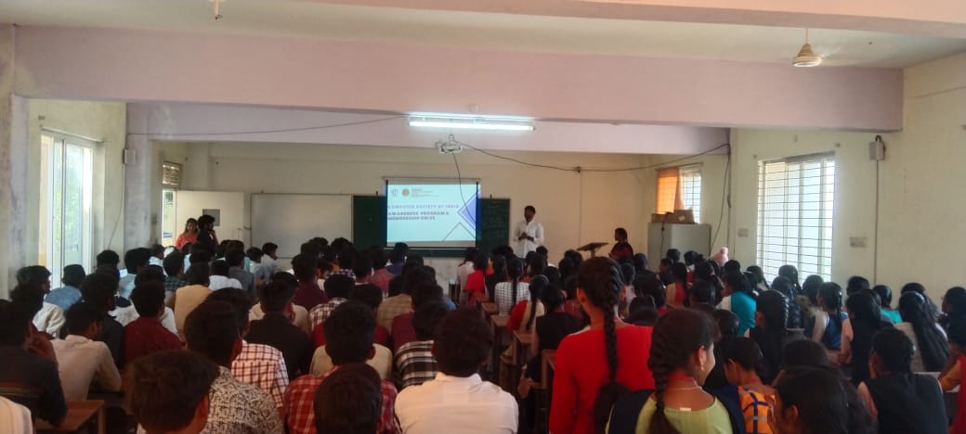Thank You

