4.5.3: Participation In Inter-Institute Events By Students Of The Program Of Study:

Academic Year: 2022-2023
Students received Prizes /Awards at Various Events
S. No | Name of the Student | Event Details
1. | THAKUR AMITH SINGH | Selected for JNTUH SOUTH ZONE INTER UNIVERSITY HOCKEY (MEN) CHAMPIONSHIP at Bharathidasan University, Tamilnadu.
2. | CHAGANTI RAKESH | Selected for the event YUVA SANGAM at IIT Roorkee , Uttarakhand.
3 | DAMERA SUDHAN | Selected for the event YUVA SANGAM at IIT Roorkee , Uttarakhand.

Academic Year: 2021-2022
Students received Prizes /Awards at Various Events
S. No | Name of the Student | Event Details
1. | CHANDANALA ARAVIND | Got 3rd Prize in Paper Presentation at Technical Fest-2022, KITS,WGL.
2. | NAGARJUNA ANUMULA  MOHAMMAD NAJEEB KHAN | Got 2nd Prize in Paper Presentation at Technozion-2022, JITS, Nspt, Wgl.
3. | MENGANI ROSHINI | Runner Up in Painting Competition at JITS, Nspt, Wgl.
Students participated at Various Events
S. No | Name of the Student | Event Details
1. | ITIKALA UDAY KIRAN  SHETTY PAVAN KUMAR  NAYAKAPU RAVI TEJA  DAMERA SUDHAN  CHINTHA TEJASWI | Volunteered in Covid Vaccination Programme at Primary Health Care Centre, Madikonda, Kazipet.
2. | PORIKA SONU NAYAK  BYRI SAIVENKATESH | Attended as Volunteer in Ganesh Nimajjanam held on 19th September 2021, organized by Warangal Police Commissionerate.
3. | DAMERA SUDHAN  CHINTHA TEJASWI  CHIRRA NAGARAJU  GONDI KALYAN KUMAR | Volunteered in Kommala Sree Laxmi Narasimhaswamy Jathara during 18/3/2022 to 23/3/2022
4. | VALASA SHRAVYA  NALLA SREEJA | Participated in Online Hackathon On Menstrual Waste And Its Management, conducted by TSIC, Hyd.
5. | NAKKA HARIKRISHNA  MITTAGADAPALA PALSON | Participated in Design Contest, at Shreshta-22, BITS, Wgl.
6. | VASAM AKHILA  DAIDA PRADEEPA REDDY  RESHMA | Participated in Debate Competition at BITS, Wgl.
7. | PODUPUGANTI KARTHIK PREETHAM  RAMA SAINATH  BOORA AKHIL | Participated in Poster Presentation at BITS, Wgl.
8 | L. VENKATESH | Participated in NCC Combined Annual Training Camp-3 at Chirala.

Academic Year: 2020-2021
Students received Prizes /Awards at Various Events
1. | KOLLU JAYANTH KUMAR | Got 3rd Prize in Paper Presentation at Shreshta-2021, conducted by BITS, Wgl.
Students participated at Various Events
S.No | Name of the Student | Event Details
1. | SINGARAPU SHARRUN  SAI KRISHNA MACHARLA | Participated in Online Paper Presentation under the Event “ Corona- Awareness” conducted by CJITS, Jangoan.
2. | THATIKONDA ROHITH  PERIYA SAI KUMAR  PUPPALA AKSHITHA  PALLE SAIPRAKASH REDDY  PRADEEP BHOOTHAM  MITTAGADAPALA PALSON  SAMBARI SAI SUMANTH | Attended As Volunteer For 4 Days At Kommala Jathara During 27-03-2021 To 30-03-2021, Organized By Warangal Police Commissionerate.
3. | EDLA HARSHAVARDHAN  THALLAMUDI SAIKUMAR  MASAMPELLY ROSHAN | Volunteered in Food Distribution during Covid Pandemic in Coordination with Municipal Workers.
4. | VANAM SAHITHI  MEKALA KOWSHIK YADAV | Active NSS Member, helped in the Covid Vaccination Drive conducted by Govt Of Telangana.
5. | VYJAYANTHULA NISHITH GADHADHARSHARMA  DATLA RAHUL  GADDAM SAINIVED | Participated in Online Competition For Making Indigenous Hand Sanitizing Machines, organized by TSIC, Hyd.

Academic Year: 2019-2020
Students received Prizes /Awards at Various Events
S.No | Name of the Student | Event Details
1. | PALLE SAIPRAKASH REDDY  ILONI SUNIL  MOHAMMAD FAYAZ | Got 2nd Prize in Poster Presentation at Shreshta-2019, conducted by BITS, Wgl.
2. | SHAIK UMAR ADNAN  SHERLA SHIVAKRISHNA | Winner in Robo Race at Non Technical Events conducted by SRIT, Wgl.
3. | ENDURI RAJESH  MIDIVELLI SRAVAN  JANGILI DEEPAK  MOHAMMAD RIYAZ ALI | Got 2nd Prize in Technical Quiz Competition conducted by Jayamukhi Institute Of Technological Sciences, Nspt, Wgl.
4. | IPPA SAI SREEJA | Secured Runner Up Position in Singing Competition conducted by Jayamukhi Institute Of Technological Sciences, Nspt, Wgl.

Students participated at Various Events
S.No | Name of the Student | Event Details
1. | MOHAMMAD SALMAN AQIB  BOJJA ARAVIND YADAV | Participated in Paper Presentation at Shreshta-2019, conducted by Bits, Wgl.
2. | MANGALAPELLY MADHU  NARIGE VEERA SWAMY | NCC Cadet who actively collected the Donations for Kerala Flood Victims and handed over to Then District Collector, P J Patil.
3. | JANGILI DEEPAK | Participated in Dance Competition at JITS, Nspt, Wgl.
4. | KATHI VINAYKUMAR  EEKA SAI CHARAN | Volunteered in Basic Eatables Distribution during Covid Pandemic in Coordination with Municipal Workers.
5. | THARIGOPPULA RAKESH | Participated in Springspree-2019 oragnized by NIT, Warangal.
6. | PUPPALA AKSHITHA  THUMMANAPALLY  ADITHYA KESHAV | Actively Participated in the Rally conducted by GWMC, Swachh Bharath Abhiyaan.
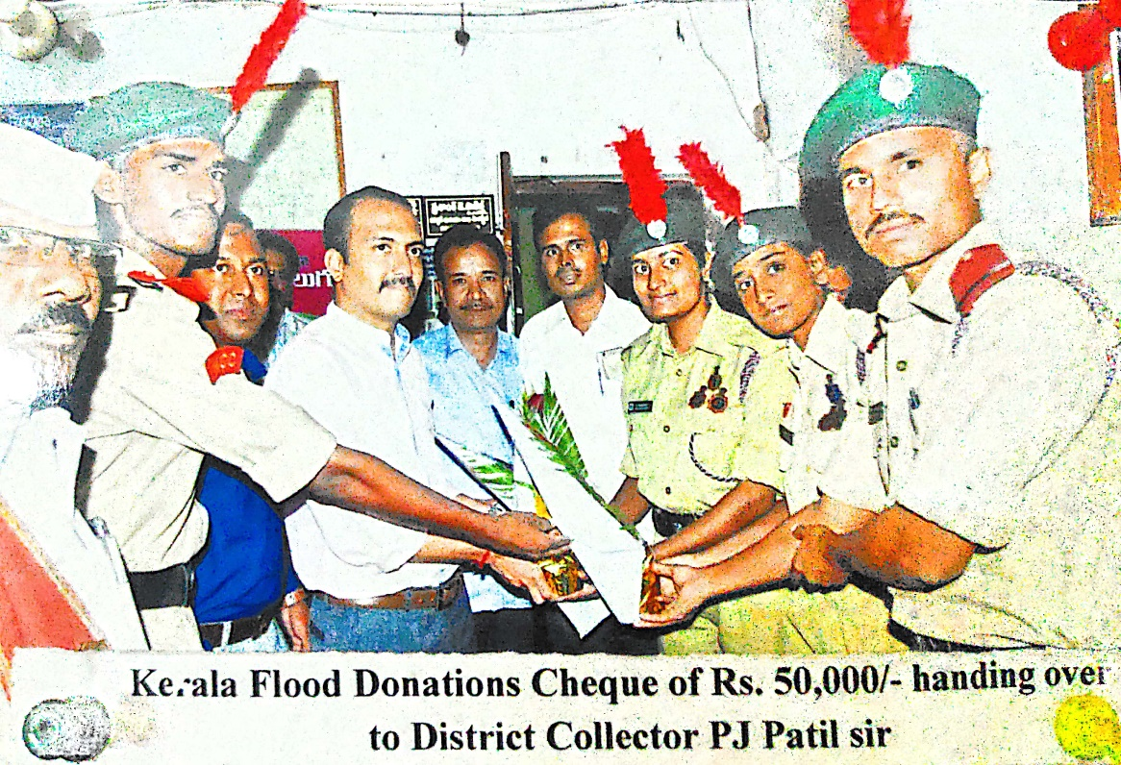

S. No. | Assessment Year | No. of Events |  | No. of Awards
S. No. | Assessment Year | Within State | Out of State | Within State | Out of State
1 | 2022-23 | - | 2 | - | 2
2 | 2021-22 | 8 | - | 3 | -
3 | 2020-21 | 5 | - | 1 | -
4 | 2019-20 | 6 | - | 4 | -
Total |  | 19 | 2 | 8 | 2

